Nepal College of Information Technology
Assessment
Fall 2010
Program: ELX Time: 3 hrs
Semester: Fall (V) FM: 100
Subject: Signal and System PM: 50

The figures in the margin indicate full marks.
Attempt all the questions:
1 a) Define invertibility of a system. Consider a discrete time system with input x[n] and output y[n]. The input – output relationship for this system is y[n] = x[n].x[n-2]
i) Is this system memoryless?
ii) Determine the output of the system when the input is Aδ[n], where A is any real or complex number.
iii) Is the system invertible? [8]
b) What do you mean by Transformation of a signal? Given the signal x(t) as shown below, sketch the following signals: [7]
i) x(t+1)
ii) x(-t+1)
iii) x(3t/2+1)
iv) x(3t/2)
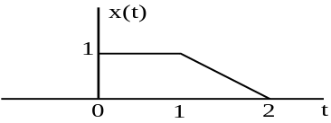
2. a) Determine the Fourier series of the following waveform and plot the magnitude and phase spectrum. [8]
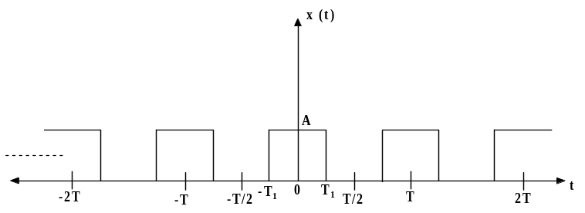
b) Sketch and find the Fourier Transform of the signal x(t) given by x(t) = 5[u(t+3)+ u(t+2)- u(t-3)- u(t-2)] [7]
3. a) Determine the circular convolution of the sequences [8]
x₁(n) = {2, 5, 3, 6}
x₂(n) = {4, 3, 2, 2}
b) Differentiate DTFT and DFT. Calculate DFT of the following sequence x[n] = {1, 4, 2, 5}. [7]
4. a) Consider the signal
x[n]= 1+sin (2π/N)n+ cos (2π/N)n + cos(4πn/N +π/2) which is periodic with period N. Find the Fourier coefficients and also plot magnitude and phase spectrum. [8]
b) Derive the condition for an LTI System to be [7]
i) BIBO stable
ii) Causal
5. a) Determine the output of an LTI system when the input is
x(t) = e^{2t} u(-t) and the impulse response is h(t) = u(t-3). [8]
b) Why direct form-two realization of LTI system is better? Construct direct form-II realization of LTI system described by difference equation which is given below.
2y(n) + y(n - 1) - 4y( n- 3) = x(n) + 3x(n - 5) + 2x(n – 2) [7]
6. a) Define FIR and IIR system. Which one is easy to realize and why? Explain. [7]
b) Define Ideal Low pass filter. Also, justify why any ideal filter cannot be realized in practice? [8]
7. Write short notes on (Any Two): [5*2=10]
a) Parseval’s theorem for aperiodic signals.
b) Applications of FFT.
c) Causal and non causal system.

